# Project report

# Oscillator networks

Kovalev Vyacheslav.

1. Abstract

Synchronization of oscillators, a phenomenon found in a wide variety of natural and engineered systems, is typically understood through a reduction to a first-order phase model with simplified dynamics. Here I examined the dynamics of a ring of quasi-sinusoidal oscillators beyond first order. Beyond first order, i found exotic states of synchronization with highly complex dynamics, including weak chimeras, decoupled states, and inhomogeneous synchronized states. Through theory I show that these exotic states rely on complex interactions emerging out of networks with simple linear nearest-neighbor coupling. This work provides insight into the dynamical richness of complex systems with weak nonlinearities and local interactions.

1. Purpose of the work

Research dynamic of complex systems with weak nonlinearities and local interactions.

1. Problem statement

Main equation:

$A_{j}$– is the complex amplitude of each oscillator j given by:

$$\begin{aligned}\frac{dA_{j}}{dT}=-\frac{A_{j}}{2}+\frac{A_{j}}{2\left|A_{j}\right|}+i\left[ω_{j}A_{j}+α{\left|A_{j}\right|}^{2}A_{j}\right]-iβA_{j}+i\frac{β}{2}\left(A_{j-1}+A_{j+1}\right) \#\left(1\right)\end{aligned}$$

Where parameters:

* $ω_{j}$ is the natural frequency of each oscillator.
* $α$ is the real number gives the nodal nonlinearity that couples frequency to amplitude.
* $β$ is the is a real number representing the strength of the coupling between nearest neighbors.

Where variables:

* $T$ is the scaled time defined in terms of the physical time t via $T =2p ×\frac{t}{t_{slow}}$; $t_{slow}=Q_{m}/f_{m}$  
  ; $Q_{m}$ is the quality factor $≈$ 4000; $f_{m}$ is the resonant frequency of the mechanical cavity $≈2.2 MHz$

Equation (1) can be separated into real and imaginary parts $\left|A_{j}\right|= a_{j}-$ amplitude, $∠A_{j}=ϕ_{j}$– phase.

$$\begin{aligned}\frac{da_{j}}{dT}=\frac{1-a_{j}}{2}-\frac{β}{2}\left[a_{j+1}\sin\left(ϕ_{j+1 }-ϕ_{j}\right)+a_{j-1}\sin\left(ϕ_{j-1}-ϕ_{j}\right)\right] \#\left(2a\right)\end{aligned}$$

$$\begin{aligned}\frac{dϕ_{j}}{dT}=ω_{j}+αa_{j}^{2}-β+\frac{β}{2a_{j}}\left[a_{j+1}\cos\left(ϕ_{j+1}-ϕ_{j}\right)+a_{j-1}\cos\left(ϕ_{j-1}-ϕ_{j}\right)\right] \#\left(2b\right)\end{aligned}$$

Assumption of small perturbation of $a_{j}$ (when $a_{j}=1$) can be written to order of $Ο\left(β\right)$ $δa_{j}≈-β\left[\sin\left(ϕ_{j+1}-ϕ_{j}\right)+\sin\left(ϕ_{j-1}-ϕ_{j}\right)\right]$, then phase turns to:

$$\frac{dϕ_{j}}{dT}=ω_{j}+α-β \\ -2αβ\left[\sin\left(ϕ_{j+1}-ϕ_{j}\right)+\sin\left(ϕ_{j-1}-ϕ_{j}\right)\right] \\ +\frac{β}{2}\left[\cos\left(ϕ_{j+1}-ϕ_{j}\right)+\cos\left(ϕ_{j-1}-ϕ_{j}\right)\right] \\ +\frac{β^{2}}{4}\left[\sin\left(ϕ_{j+2}-ϕ_{j}\right)+\sin\left(ϕ_{j-2}-ϕ_{j}\right)\right] \\ -\frac{β^{2}}{2}\left[\sin\left[2\left(ϕ_{j+1}-ϕ_{j}\right)\right]+\sin\left[2\left(ϕ_{j-1}-ϕ_{j}\right)\right]\right] \\ -\frac{β^{2}}{4}\sin\left(ϕ_{j+2}-2ϕ_{j+1}+ϕ_{j}\right) \\ -\frac{β^{2}}{4}\sin\left(ϕ_{j-2}-2ϕ_{j-1}+ϕ_{j}\right) \\ \begin{aligned}+\frac{β^{2}}{2}\sin\left(ϕ_{j+1}-2ϕ_{j}+ϕ_{j-1}\right) \#\left(3\right)\end{aligned}$$

At $Ο\left(β\right)$ this reduces to the Kuramoto-Sakaguchi equation.

$$\begin{aligned}\frac{dϕ_{j}}{dT}=ω_{j}+α+K\sum_{i=j-1,j+1}{\left\{\sin\left(ϕ_{i}-ϕ_{j}\right)+γ\left[1-\cos\left(ϕ_{i}-ϕ_{j}\right)\right]\right\}} \#\left(4\right)\end{aligned}$$

Where $K=-2αβ;γ=\frac{1}{4α};$

1. Symmetry

Synchronization is supposed to be symmetrical for this I will use table1.

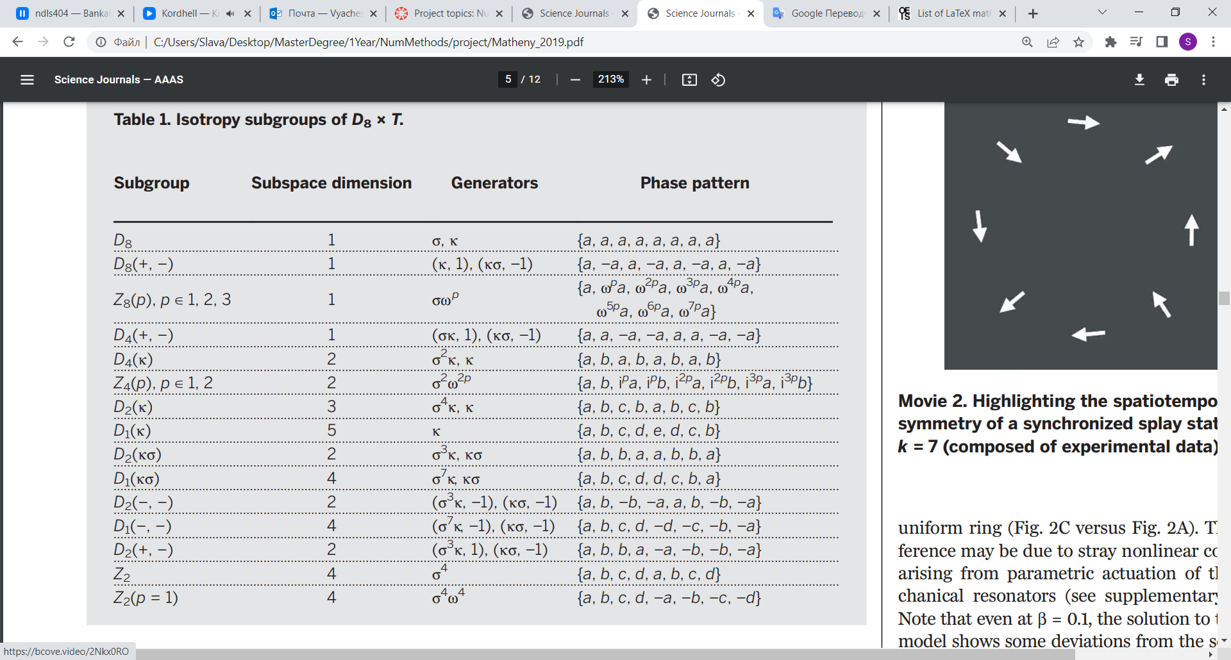

1. First step

For all following steps $ω_{j}=0$.

I tried to solve general equation (2) with Euler explicit scheme.

$$a_{j}\left(0\right)=1;ϕ_{j}\left(0\right)=rand;β=0.4; α=0.08;$$

At fig1 you can see $∆_{j}=\left(ϕ_{j+1 }-ϕ_{j}\right)mod\left(2π\right)$ phase difference and $a_{j}-$ amplitude. $∆_{j}=π$ for all j means that all nodes in antiphase (D8(+,-) group) (you can see movie k4.mp4). we can get conclusions:

1. System synchronizes very fast => count of points might be small => stability factor is unimportant for this task.
2. It hard to predict how small time step have to be

There for best choice is to use Adaptive Runge–Kutta method.

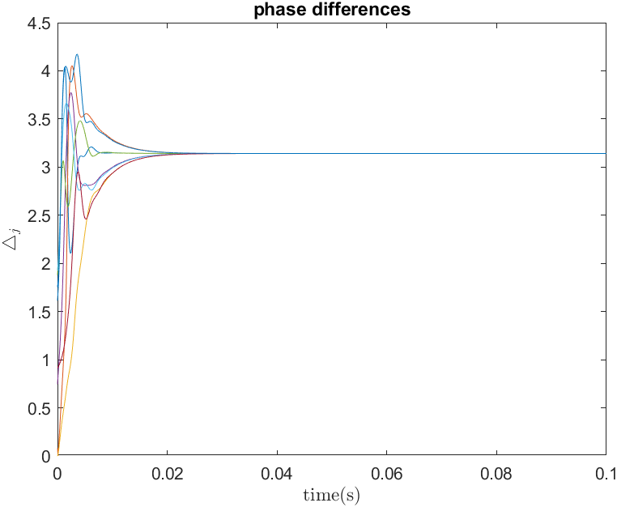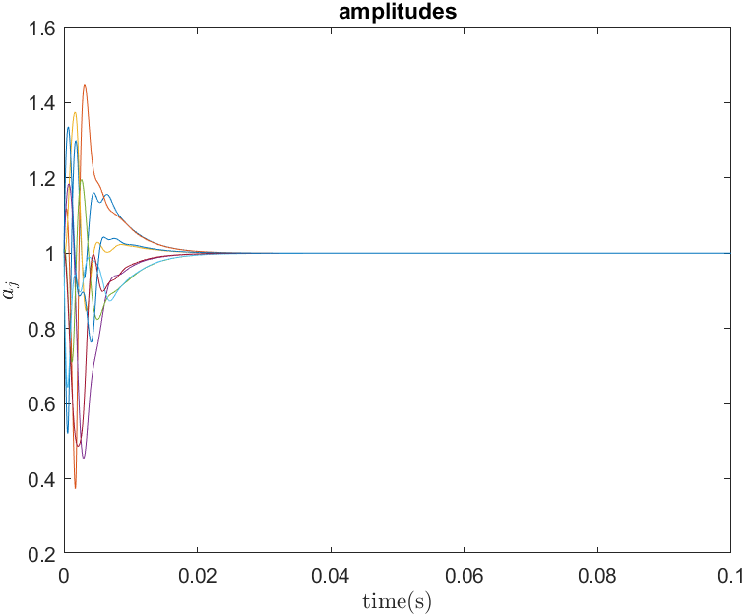

Fig1. Euler explicit, equation (2). Phase diff. and amplitude.

I performed a lot of attempts using initial conditions: $$a_{j}\left(0\right)=1;ϕ_{j}\left(0\right)=rand;β=0.4; α=0.08;$$

But result of synchronization always was different (in terms of symmetry table1) it leads to probability model when we can only estimate probability of this symmetry state.

Also I can conclude that amplitude perturbation always is big, therefore here and below I will use only general eq(2).

1. Probability of symmetry states

Lets research probability of arising symmetry states using formula:

$$\begin{aligned}k=\frac{1}{2π}\sum_{j=1}^{N}{∆_{j}} ,k=0,…N-1 \#\left(5\right)\end{aligned}$$

In our case we expect $∆_{j}$ at the end of synchronization almost the same for all nodes, therefore $k=0$ is inphase state, k = 4 is antiphase, other splay states $k=1,2,3,5,6,7$.

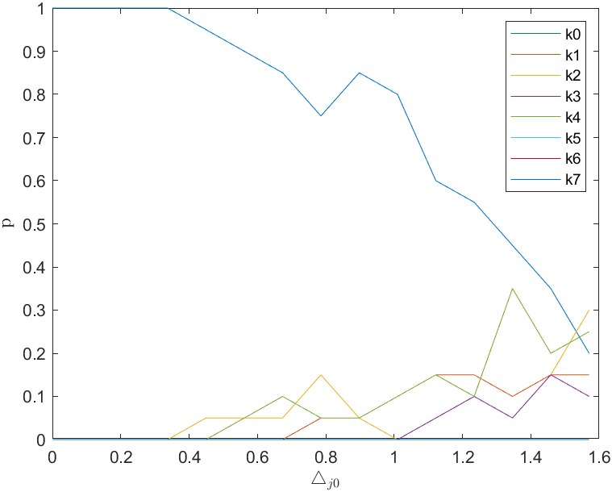I created 10 samples and changed initial $∆j_{0}$  
(it means that $ϕ_{1}-ϕ_{2}∈[-∆_{10},∆_{10}]$ and so on) and check probability arising $k$ state in this 10 samples for each $∆j_{0}$.

Probability of arising k state depending on $∆_{j0}$

1. Dependence on $α,β$ parameters.

To research dependence on $α,β$ parameters let’s fix $∆_{j0}∈[-\frac{π}{20};\frac{π}{20}]$.

$α∈\left[0.04,0.18\right], β∈\left[0.1,1\right]$. I plotted results of absolute value $M$, where $Mexp\left(iΦ\right)=\frac{1}{N}\sum_{j=1}^{N}{\exp\left(iϕ_{j}\right)}$. If $M=1$ then our nodes in-phase (white $\{k=0\}$), if $M <0.5$ it is other synchronized state (black and red $\{k=1,2,…7\}$), if $0.5<M<1$ it is imhomogeneous synchronization.

1. 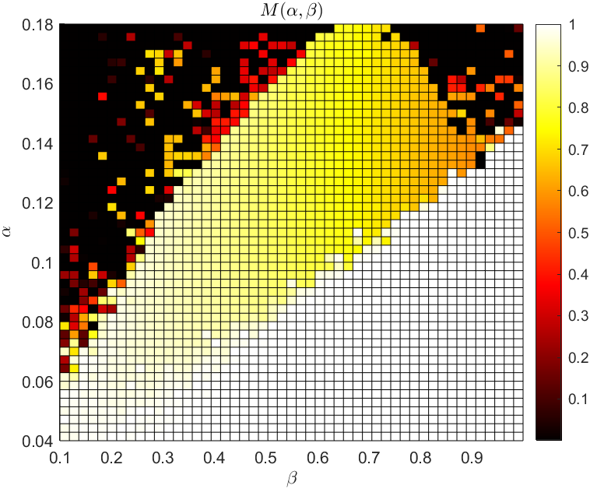Weak chimera

A lot of experimental results shows that states with both a coherent synchronized region and an incoherent region are possible. Also called weak chimeras.

Where $0.5<M<1$ I found weak chimeras:

|  |  |
| --- | --- |
|  |  |

You also have to see chimera.mp4. As you can see amplitudes are different it means that frequencies are different and we have incoherent state. Our system divides by clusters each of them preserve some kind of symmetry and almost the same frequency.

Extra sample:

|  |  |
| --- | --- |
|  |  |

And movie chimera2.mp4. It seem like it doesn’t synchronized, but in the movie you can find pairs that phase difference the same in time, it means that our system losses symmetry as a group of 8 nodes, but all nodes divides by groups each of them always have symmetry in terms of phase, amplitude and frequency.

1. Conclusion

I demonstrated that a simple ring of eight self-sustained nanoelectromechanical oscillators with linear, nearest-neighbor coupling exhibits exotic states of synchronization with complex dynamics and broken symmetries.